BIP PIONEER ECR TRAINING SCHOOL 2026


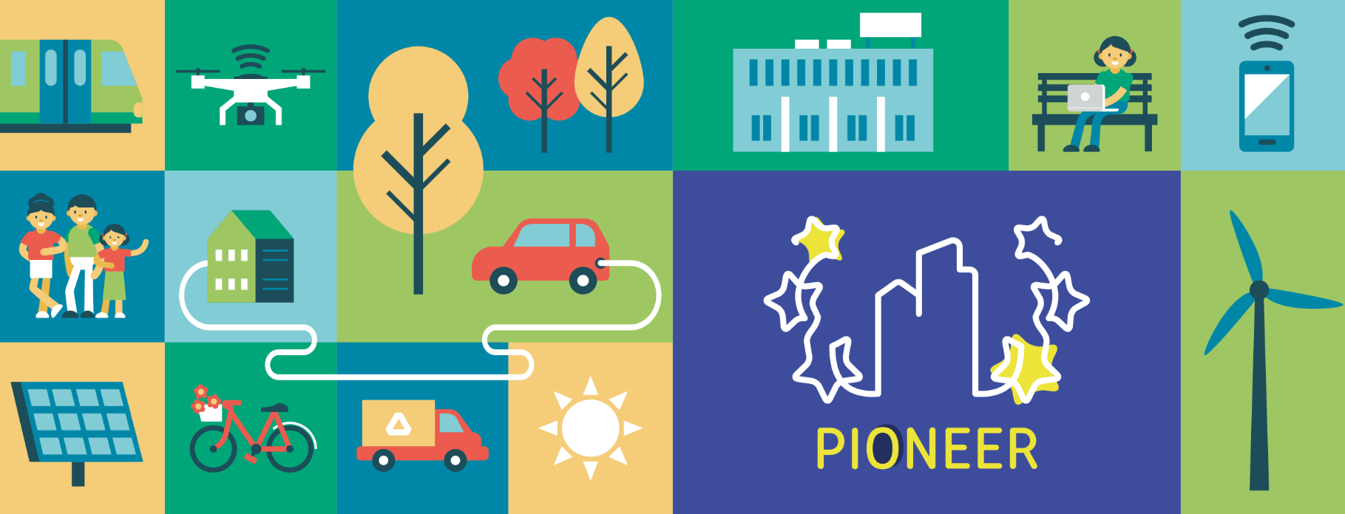
This project is co-funded by the European Union under the Erasmus+ programme Grant Agreement n°101177236
Co-Funded by the European Union. Views and opinions expressed are however those of the author(s) only and do not necessarily reflect those of the European Union. Neither the European Union nor the granting authority can be held responsible for them.
ORGANISATION
- Avans UAS – COORDINATOR / HOST INSTITUTION
- ISCTE – Instituto Universitárion de Lisboa – CO-COORDINATOR
- PIONEER Alliance universities – PARTNERS

BIP ID: TBA summer 2026

PHYSICAL ACTIVITY: 28/09/2026 – 2/10/2026
The on-site component will take place at Avans UAS, Onderwijsboulevard 215 in ‘s-Hertogenbosch, The Netherlands

VIRTUAL ACTIVITY: before and after physical activity
This mobility will be organised as an Erasmus+ BIP and therefore, it is mandatory to participate in both virtual and on-site components.

- 14/09/2026 – 1.00 – 3.00 PM CET (Amsterdam Time)
- 21/09/2026 – 2.00 – 5.00 PM CET (Amsterdam Time)
- 15/10/2026 – 1.00 – 4.00 PM CET (Amsterdam Time)

LANGUAGE: English
ELIGIBLE PARTICIPANTS: staff and doctoral students from PIONEER Alliance universities
REGISTRATION DEADLINE: 15 April 2026
Please register for participation before April 15th via the link on the website. Each registered participant will be requested to confirm participation before May 1st, 2026.
COST: The BIP has no registration fees. All activities offered in the program are free of charge, unless otherwise specified. Accommodation and travel costs should be borne by participants and/or their universities.
INFORMATION CONTACT
- For any questions regarding Programme virtual and physical activities: Ms. Robin PEREBOOM (cr.pereboom@avans.nl), Ms. Guya ACCORNERO (guya.accornero@iscte-iol.pt
- For any questions regarding Application process, Erasmus+ and BIP processes: Ms. Isis SUTMULLER (i.sutmuller@avans.nl) or Ms. Robin PEREBOOM

BIP PIONEER EARLY CAREER RESEARCHER TRAINING SCHOOL - Abstract
Avans University of Applied Science coordinates the Blended Intensive Program (BIP) “PIONEER Early Career Researchers Training School”.
This first edition PIONEER training school, taking place in September 2026, helps early career researchers to create meaningful impact in societal SDG11 challenges, through impact-driven transdisciplinary research. As a researcher, you have an active role in turning today’s challenges into a better tomorrow through research. We will show you how.
Today’s world is shaped by complex, interconnected challenges, issues no single discipline can solve alone. As an early career researcher, you are in a crucial position to rethink how knowledge is created and how research can genuinely drive societal change. Within the Pioneer alliance we combine our strengths and unique perspectives to work on societal challenges together and within (local) and global communities.
In this Pioneer Training School, you will step beyond traditional academic boundaries and work hands-on with a real-world challenge linked to SDG 11: Sustainable Cities and Communities. Using an urban redevelopment project in Den Bosch as a living case, you’ll engage directly with stakeholders, explore multiple perspectives, and practice working in real contexts where uncertainty and creativity go hand in hand.
Throughout the week, you will develop the core transdisciplinary skills that future-proof your research career: collaboration across sectors, perspective-taking, participatory research methods, creative inquiry, and impact-driven thinking. The collaborative approach ensures that all participants benefit and learn, to fundamentally transform the world. In this pioneer training school, we will provide you with theory and hands-on experience to develop these skills to become an impact-driven researcher.
We also explore AI as a responsible ally in transdisciplinary research. Through practical exercises, you’ll discover how AI can enhance stakeholder engagement, enrich sense-making, support science communication, and help you design better research—ethically and effectively.
Finally, this training school strengthens one of your most important assets as an early career researcher: your international and community network. Trust and long-lasting relationships help engage stakeholders within your research project. Networking skills, internationally, interculturally and interpersonally, are an important skill to develop as an early career researcher. In this training school, we dedicate time to train these skills and build your network internationally, but also within your local communities.

DRAFT PROGRAMME

* This programme is indicative. The program is under construction and may be subject to change.

** Phd doctoral students will receive 3 ECTS upon completion of this training school. University staff members will receive a certificate upon completion of this training school

Online session 1. Get ready…  Monday 14 September 2026, online  Online session 2. Set…  Monday 21 September 2026, online | In two online sessions, supported by some reading and preparation activities (information to follow), you will be introduced to the training school and the PIONEER Alliance. A guest speaker will provide an introduction to the societal challenges related to SDG11. You will get an introduction to transdisciplinary research (TDR) and AI in societal context and research. The second session will be split up in smaller work groups.
Day1. GO! Perspectives on Research & Impact  Monday 28 September 2026, Den Bosch | Morning: Registration & Welcome, Kick-off of PIONEER ECR Training School  Networking lunch at Avans Campus  Afternoon: Perspectives on Research and Impact  Through interactive activities, participants get to know one another and explore the diverse perspectives they bring to research and how to create impact with it. This day emphasizes not only thinking about research but also actively doing it, encouraging hands-on engagement, curiosity, and experimentation from the very start.  Evening: City Tour of Den Bosch
Day2. Designing collaborative research  Tuesday 29 September 2026, Den Bosch | Morning: Site-visit urban redevelopment project city Den Bosch  In groups you will work together on research related to a challenge which will be introduced by the municipality of Den Bosch. This will be an interactive session in which the challenge can be investigated from different perspectives and designed in co-creation.  Afternoon: Designing collaborative TD research  In the afternoon, you dive into collaborative transdisciplinary research design and methodologies. This hands-on experience helps you understand how different research forms can drive engagement, co-creation, and meaningful impact. You can use this to apply to the case you’re working on as a team.  Evening: Free evening
Day3. AI in transdisciplinary research  Wednesday 30 September 2026, Den bosch | Morning: AI in trandisciplinary research  Speakers of ISCTE will share theory and experiences of role of AI as an interface between citizens, institutions and science. Further topics such as ethics and inequality in big data will be addressed as well as role of AI within research processes, from project proposal, data collection, analyses, result delivery and scientific communications.  Afternoon: Inspiring TDR practices  Carroussel; examples of SDG11 research projects, and (invited) researcher paneldiscussion. Become inspired by the variety of impact-driven researchproject presented by Avans and ISCTE.  Evening: Network Dinner
Day4. Impact and Networks  Thursday Oct 1st 2026, Den Bosch | Morning: Understanding Impact  You explore how impact is seen, felt, and created, linking these insights to your own research and the Inner Development Goals.  Afternoon: Building and maintaining international networks  Develop your network skills! Why is it important to build your network? What can you do now, to make sure your international network is strong? Also: good relations with your local communities.  Evening: Closing dinner and event in Den Bosch
Day5. Showcasing and goodbyes  Friday Oct 2nd 2026, Den Bosch | Morning: Student’s presentations on learning objectives and challenge  On the final day, you present the insights and outcomes of your weeklong collaborative groupwork on the Den Bosch research challenge. You share experiences, reflect on your transdisciplinary researchskills, and consider how to bring these lessons into your own research contexts. The program concludes with discussions on staying connected as an international community, followed by heartfelt goodbyes.  Closing lunch & looking forward to “Accelerating the Future”  Afternoon: departures
Online session 3: Accelerating the future.  Thursday 15 October 2026 | The content of this session will be announced later.

